Silicon photonics phase-shifted Bragg-grating filter for temperature sensing applications

Lucivaldo B. Aguiarª, Moises A. Oliveiraª, Murilo A. Romero^{b*}, Adolfo F. Herbster^{a*}
ªElectrical Engineering Department, Federal University of Campina Grande - UFCG, Campina Grande, PB, Brazil; ^{b}Electrical and Computer Engineering Department, University of Sao Paulo – EESC/USP, Sao Carlos, SP, Brazil
*corresponding authors: murilo.romero@usp.br, adolfofh@dee.ufcg.edu.br

Abstract
A novel photonic integrated circuit is designed and demonstrated for temperature sensing applications. The device is based on a silicon-photonics Bragg grating (BG) structure. It also incorporates three phase-shifting sections, in such way to open up a transmission window in the BG optical stopband, thereby creating a passband filter response for the structure. Our scheme employs a dual-wavelength amplitude measurement of optical transmission across the filter, to assess temperature variations, while simultaneously cancelling the effects of spurious amplitude fluctuations unrelated to temperature change. The filter was fabricated over a SOI platform using the Canadian foundry Applied Nanotools. Experimental characterization yielded a 3-dB bandwidth of approximately 4 nm, and a maximum rejection of about 15 dB. An initial performance evaluation of the complete sensor circuit was simulated across the operation range of 280–350 K, indicating excellent linearity, with an optical power sensitivity of 0.39 dB/K.
Keywords: temperature sensor, photonic integrated circuit, integrated optics, silicon photonics, Bragg gratings

INTRODUCTION
Temperature is the dominant factor regarding battery lifespan and performance. Operating a battery below its optimum temperature range can lead to a (usually temporary) battery capacity reduction. On the other hand, high temperature operation accelerates aging and can drastically reduce the battery lifetime [1]. Also, extreme temperatures can lead to thermal runaway and pose important security risks [2]. In short, there is a clear need for temperature monitoring for thermal management purposes, to assure proper operating temperatures during the whole battery cycle.

Fiber-optic Bragg gratings (FOBGs) were first fabricated in 1978 [3] and started to find widespread use after the transverse holographic inscription technique was demonstrated in 1989 [4]. Then, since the early 90´s, FOBG-based optical sensors have attracted a great deal of attention in a variety of sensing applications, including temperature monitoring [5]. More recently, the rising of silicon photonics, with Bragg-grating writing capabilities, provides a path to revisit and extend some of the previous optical sensor designs. Integrated optics offers small footprint and compactness, while allowing mass production with excellent repeatability.

When using BGs to monitor temperature, one can attempt to directly track the resonance wavelength shift as function of the temperature variation. In the early days, this amounted to implementing some kind of interferometric detection scheme [5]. Today, this task could be carried out by an Optical Spectrum Analyzer (OSA) Results are accurate, but the OSA is expensive and bulky. An alternative is to implement an intensity-based sensor, employing a fixed wavelength, and measure the detected amplitude variation as the BG spectral response changes. The sensor is much simpler, but accuracy suffers, on account of random fluctuations on the detected optical power levels.

In this work, we propose and demonstrate a silicon-based photonic integrated circuit (PIC) designed to overcome these shortcomings by means of a self-referencing dual-wavelength scheme. As we detail in the next sections, the PIC is based on the combination of Bragg-grating (BG) waveguides, separated by and phase shifting sections in between them, in such way to produce a passband filter optical response. The present silicon-photonics, integrated-optics PIC revisits and reduces to practice a theoretical proposition by one of us, for a fiber-optics BG temperature sensor [6]. For the sensor operation, the two wavelengths are deployed in such way that λ₁ is placed in the filter passband while λ₂ is located in the slope to the stopband. As the temperature changes, the optical filter spectral response shifts. Then, the transmittivity at the wavelength λ₂ will be drastically altered while it will remain essentially invariant at wavelength λ₂, which provides a reference to cancel out spurious amplitude fluctuations.

Bragg grating

Fundamental Concepts
A Bragg grating (BG) is a distributed Bragg reflector constructed by creating a periodic variation of the refractive index in the waveguide core, thereby generating a wavelength-specific dielectric mirror. This Bragg wavelength, ${\text{λ}}_{\text{B}},$and its spectral shift as a function of the tempeature variation are given by, respectively [7]:

 | $$\begin{aligned}{\text{λ}}_{\text{B}}\text{ = 2} {\text{n}}_{\text{eff}} \text{Λ}\end{aligned}$$ | (1)

 | $$\text{Δ}{\text{λ}}_{\text{B}}\text{ =}{\text{λ}}_{\text{B}}\left(\text{ε + }\text{α}\right)\text{Δ}\text{T}$$ | (2)

where ${\text{n}}_{\text{eff}}$is the waveguide effective refractive index, $\text{Λ}$is the grating period, ε is the normalized thermooptic coefficient and α is the thermal expansion coefficient.

Waveguide Bragg Grating Design Incorporating Phase-Shift Sections
A uniform WBG is a distributed Bragg reflector, constructed by a periodical modulation of the effective refractive index in the direction of propagation [7]. The seminal work by Zengerle and Leminger used coupled-mode theory associated to the transfer matrix formalism to demonstrate that the combination of M uniform BGs with M-1 phase-shift sections allows one to open a filter-like transmission window within the stopband of the WBG [8]. By a judicious choice of the parameters of the whole structure, the transmission spectrum can be tailored to provide a designed spectral response.
In our design, we used the EigenMode Expansion (EME) solver from the software package Tidy3D, by Flexcompute. EME is a frequency-domain method which provides the bidirectional scattering matrix along the propagation axis of long waveguides devices. The optimization of the geometrical parameters is crucial because there are a series of trade-offs involved in the sensor filter design. For instance, an increase in the grating depth improves the extinction ratio but reduces the optical bandwidth. Conversely, increasing the number of sections increases the optical bandwidth but also increases the ripple in the optical passband, which is detrimental to the temperature measurement accuracy.
After the simulations, and accordingly to the schematic diagram depicted in Fig. 1, two designs were selected, WBG 1 and WBG 2. Both designs use M = 4. The geometrical parameters for each design are given in Table 1 while the simulated optical spectrum for WGB 1 is illustrated in Fig. 2. The two wavelengths indicated in Fig 2 are deployed in such way that λ₁ is placed in the filter passband while λ₂ is located in the slope to the stopband. As the temperature changes, the optical filter spectral response shifts. Then, the transmittivity at the wavelength λ₂ will be drastically altered while it will remain essentially invariant at wavelength λ₁, which provides a reference to cancel out spurious amplitude fluctuations.

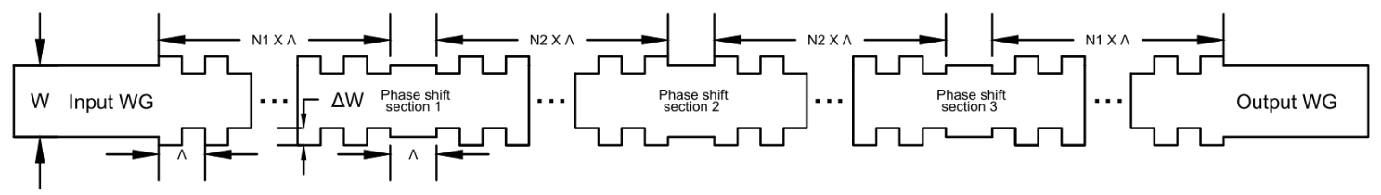
Figure 1. Schematic design of the WBG sensor. Each design has four uniform BG sections.

Table 1. Geometrical parameters for the two designs. N₁ and N₂ are the number of periods.
W is the waveguide width and ΔW is the grating depth.
Device | N1 | N2 | Λ[nm] | W[nm] | ΔW [nm] | Total length [μm]
WBG 1 | 45 | 105 | 320 | 500 | 20 | 96.96
WBG 2 | 40 | 88 | 320 | 500 | 30 | 82.88

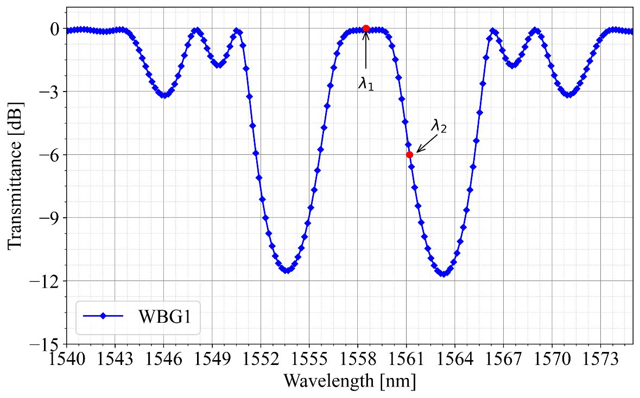
Figure 2. Optical spectral response for the design WBG 1.

fabrication and experimental results for the wbG designs

Spectral Measurements Results for the Fabricated WBGs
The designed WBGs were fabricated by the foundry Applied Nanotools, as part of the Program openEBL, offered by the Canadian SiEPIC initiative, in two distinct tape-outs. The SEM image of one of WBGs is depicted in Fig. 3.

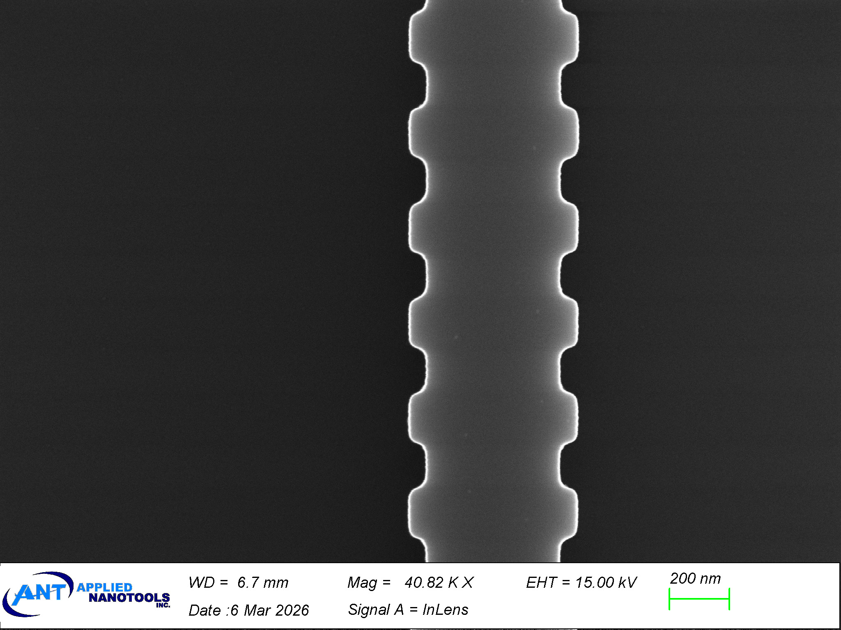
Figure 3. SEM image of one of the WBGs fabricated by the foundry Applied Nanotools.

Fig 4 illustrates a transmittance comparison between the simulated results for the original design (blue line) and the experimental results for the fabricated WBGs (red line). Also shown, the black line represents the simulated curve using the set of modified WBG parameters which provides the best fit to the experimental results. These deviations from the nominal values are mostly due to fabrication tolerances and the new set of values are described in Table 2.
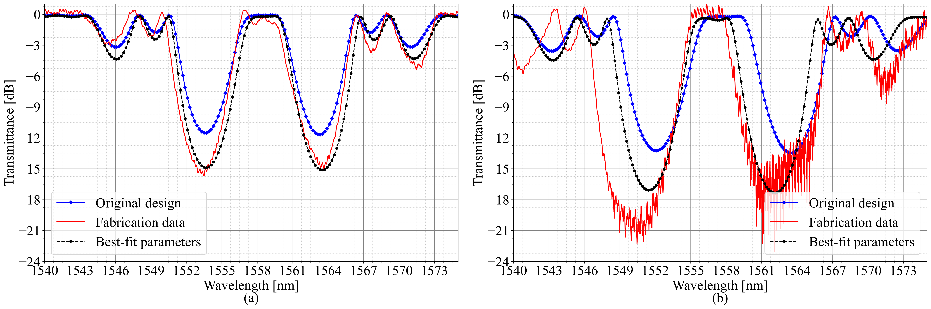
Figure 4. Transmittance comparison between the original design (blue line) and the fabricated WBGs (red line). The black line represents the simulated curve using the set of modified WBG parameters which provide the best fit to the experimental results.

Table 2. Nominal and Best-fit parameters for the WGB designs.
Configuration | ΔW_{nominal} [nm] | ΔW_{best-fit} [nm] | Total length_{nominal} [μm] | Total length_{best-fit} [μm]
WBG 1 | 20 | 26.25 | 96.32 | Unchanged
WBG 2 | 30 | 36.25 | 82.88 | 91.17

predicted sensor performance

Schematic of the Sensor Circuit
The schematic of the sensor circuit is depicted in Fig. 5. Both wavelengths are combined at the input and transverse the WBGs. At the output, both wavelengths are diverted to their respective photodetectors by the 1 x 2 MZI device. Since each WBG is described by a specific set of parameters (see Table 1), it is also necessary to design a specific MZI for each WBG configuration. The MZI design parameters are given in Table 3.
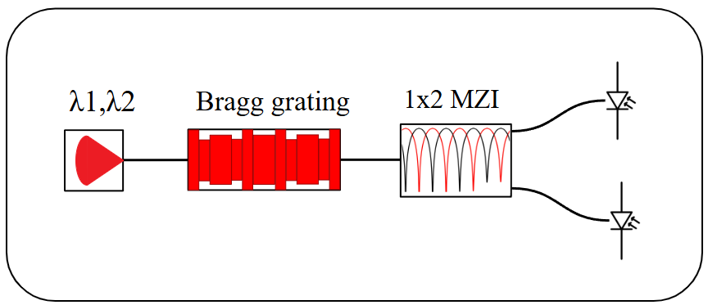
Figure 5. Schematic of the Sensor Circuit.

Table 3. Main design parameters of the MZIs for each WBG configuration: group index, path length difference between the MZI arms and free spectral range
Configuration | n_{g} | ΔL (μm) | FSR [nm]
WBG 1 | 4.5108 | 120.4 | 5.04
WBG 2 | 4.5108 | 85.41 | 6.8

Performance of the Whole Sensor Circuit – Simulation Results
Starting from the optical spectrum measurement results, as well as the best-fit parameters of the WBGs, as described in Table 2, the temperature-sensing PICs were simulated using Photonforge, also by Flexcompute. Photonforge integrate specifications and design rules directly from the foundry PDK, thereby assuring very accurate simulations, in regard to the expected experimental results. The sensor circuit response as a function of temperature is provided in Fig. 6. Also shown is the best linear fit, obtained by polynomial regression by solving the least squares problem. Table 4 summarizes the computed performance parameters for both WBGs.

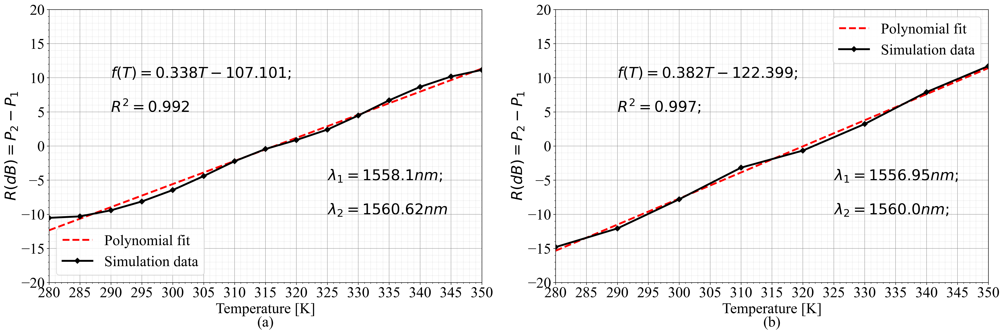
Figure 6 Computed sensor response and linear fit for the fabricated phase-shifted Bragg gratings (a) WBG1 and (b) WBG2.

Table 4. Optical Sensor Performance and Linear Response Parameters.
Configuration | Optical Power Sensitivity [dB/K] | R² | Temperature  sensing range[K]
WBG 1 | 0.338 | 0.992 | 70
WBG 2 | 0.382 | 0.997 | 70

COnclusions
In this paper we described a novel photonic integrated circuit for temperature sensing applications. The device is based on a silicon-photonics phase-shifted Bragg grating (BG) structure, thereby producing a passband filter optical response. Our scheme employs a dual-wavelength amplitude measurement of optical transmission across the filter, to assess temperature variations, while simultaneously cancelling the effects of spurious amplitude fluctuations unrelated to temperature change. The filter was fabricated over a SOI platform using the Canadian foundry Applied Nanotools. Experimental characterization yielded a a 3-dB bandwidth of approximately 4 nm, and a maximum rejection of about 15 dB. An initial performance evaluation of the complete sensor circuit was simulated across the operation range of 280–350 K, indicated an optical power sensitivity o 0.39 dB/K and a highly-linear response. The complete circuit design does not require a spectrum analyser and the targeted temperature range can be increased by WDM multiplexing of several WBGs.

Acknowledgements
This work was supported in part by the PHOSENSE DEVICES project, supported by the EMBRAPII VIRTUS Competence Center in Intelligent Hardware for Industry (VIRTUS - Centro de Competência), with financial resources from the PPI HardwareBR program of the MCTI, through Cooperation Agreement No. 055/2023 established with EMBRAPII, in part by the Brazilian Research Council (CNPq – 309343/2021-6) and in part by the Fundação de Amparo à Pesquisa do Estado de São Paulo (FAPESP – 2021/06569-1).

References
- S. Lv, X. Wang, W. Lu, J. Zhang, and H. Ni, "The Influence of Temperature on the Capacity of Lithium Ion Batteries with Different Anodes," Energies 15(1), 60 (2022). https://doi.org/10.3390/en15010060.
- Y.Q Chen et. al, “A Review of Lithium-Ion Battery Safety Concerns: The Issues, Strategies, and Testing Standards”, Journal of Energy Chemistry 59, pp 83 (2021). https://DOI10.1016/j.jechem.2020.10.017.
- K. O. Hill et. al, “Photosensitivity in Optical Fiber Waveguides: Application to Reflection Filter Fabrication", Appl. Phys. Lett. 32(10), 647 (1978)
- K. O. Hill and G. Meltz, "Fiber Bragg Grating Technology Fundamentals and Overview," J. Lightwave Technol. 15(8), 1263 (1997).
- A. D. Kersey and T.K. Berkoff, "Fiber-optic Bragg-Grating Differential-Temperature Sensor," IEEE Photonics Tech. Lett. 4(10), 1183 (1992).
- C. A. De Francisco, M.T.C. Silva and M.A. Romero, " Analytical Study of Bragg-Grating Fiber-Optic Filters for WDM and Temperature Sensing Applications," Optical Engineering, 41(7), 1491 (2002).
- R. Kashyap, Fiber Bragg Gratings, 2nd ed., Academic Press, Burlington, MA (2010).
- R. Zengerle e O. Leminger, "Phase-Shifted Bragg-Grating Filters with Improved Transmission Characteristics," J. Lightwave Technol. 13(12), 2354 (1995).

